Sustainable Supply Chain Performance

**Data Analysis** - Data analysis inspects, cleans, transforms, and models data to extract insights and support decision-making.

**Tools used for Data Analysis :–**

1. Power BI

2. Tableau

**Power BI :** It is Microsoft’s Data Analysis Tools. It provides enhanced Interactive Visualization and capabilities of Business Intelligence. Power BI achieves all this while providing a Simple and intuitive User Interface. Being a product of Microsoft, you can expect seamless integration with various Microsoft products. It allows you to connect with Excel spreadsheets, cloud-based data sources and on-premises data sources.

* Download power BI using any browser or Microsoft store.

**Create Report:**

* Open blank report import data using get data which present in the ribbon in the Power BI.

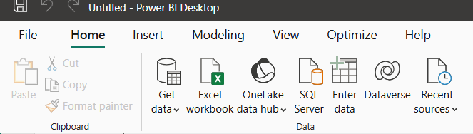

* We can import data from Excel files , CSV file, Text data and SQL server.

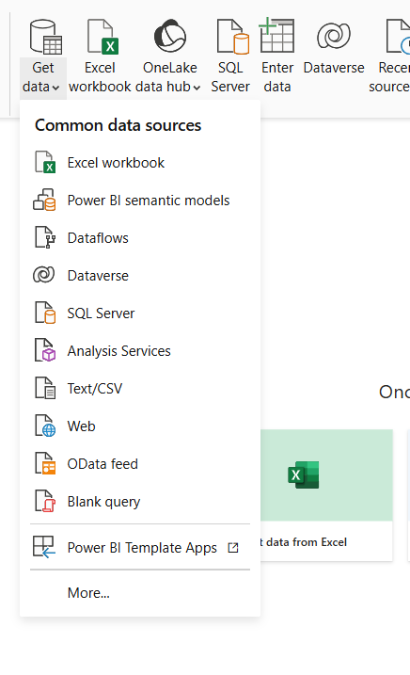

* After importing data we find the data table in that we have 2 options we can load our data or we can transform our data.

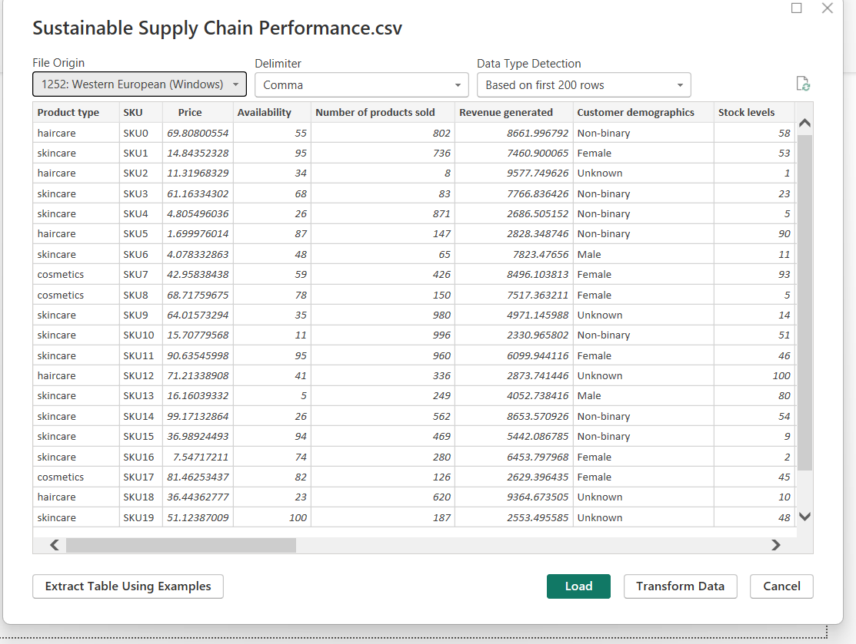

* **Extract:** used to pull data from data sources.
* **Transform :** we click on transform data when there is no accuracy in the data or when we need to clean data or when we need data processing.
* **Load :** when the data is clean and clear we can directly load our data.
* In the right side we find 3 views

1. Report View : used for visualization
2. Table View : used to see the data
3. Model View : It is used to create relation ships among the data tables.

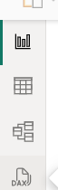

* When we click on transform data we would redirect to “**Power Query Editor”** window.

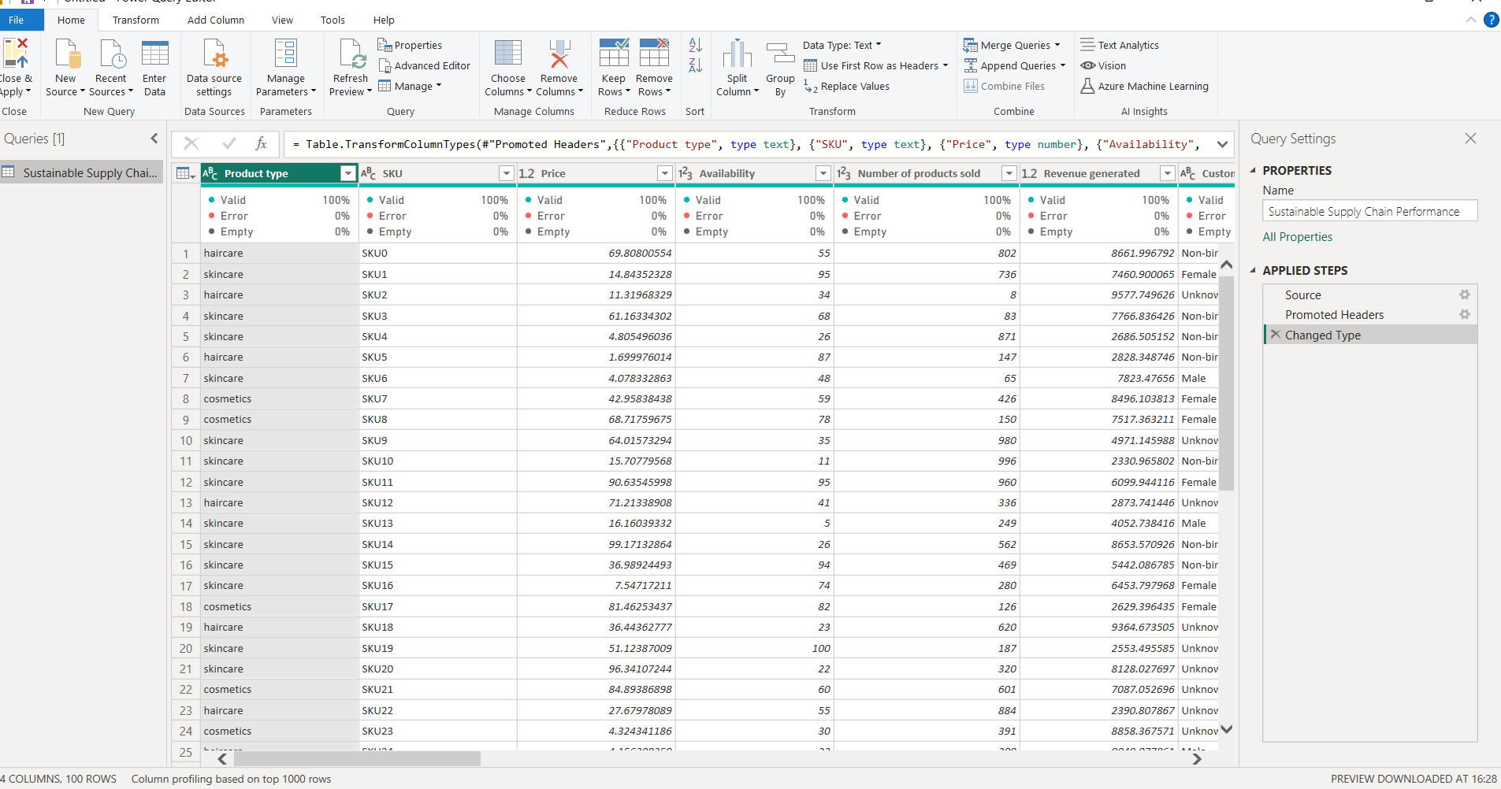

* We have sustainable supply chain performance csv file
* We should transform the data.

Table to be created:

**INVENTORY TABLE :**

1. Product type

2. SKU

3. Availability

4. Number of products sold

5. Customer demographics

6. Stock levels

7. Lead times

8. Order quantities

9. Lead time

10. Revenue generated

* After cleaning the data we should click on save and apply then we can find our data on the left side of power BI window.

